**Name Session:**

**Programming II**

# Typing Tutor Project

**Lab Exercise 4.1.2020**

1. In this project we will be making a Space Invaders-like game that is designed to improve your typing skills. Start by laying out a form as shown in figure 1. Your Form should be of size 480 x 640. The Y coordinate of Labels 1 – 5 should be at 34. lblScore should be at location (135, 573) with a size of 432 x 20.

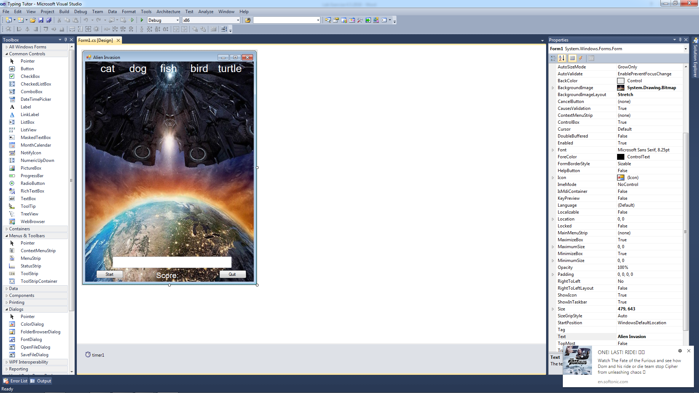

Figure 1 Typing Tutor Form

As you can see, this form will require the following Objects placed on it.

Quit button btnQuit

Start/Stop button btnStart

Score box lblScore

Cat label lblCat

Dog label lblDog

Fish label lblFish

Bird label lblBird

Turtle label lblTurtle

Text entry box txtEntry

A timer timer1

1. Create a global variable

int score;

1. Set the timer1 properties to enabled = false and interval = 30 (Increasing the timer interval will make the game less challenging. Note: timer interval is short and the labels move 5 pixels per tick to reduce screen repaint flicker.
2. Add the following to btnQuit_Click event to cause your game to end.

this.close()

1. Add the following to btnStart_Click event to start and stop your game.

if (btnStart.Text == "Start")

{

btnStart.Text = "Stop";

score = 0;

lblScore.Text = "Score: " + score;

timer1.Enabled = true;

txtEntry.Focus();

}

else

{

btnStart.Text = "Start";

timer1.Enabled = false;

lblCat.Top = 0;

lblDog.Top = 0;

lblFish.Top = 0;

lblBird.Top = 0;

lblTurtle.Top = 0;

}

1. Add the txtEntry_TextChanged event to allow your input.

if (txtEntry.Text != "")

{

if (txtEntry.Text == lblCat.Text)

{

txtEntry.Text = "";

lblCat.Top = 0;

score++;

lblScore.Text = "Score: " + score;

}

if (txtEntry.Text == lblDog.Text)

{

txtEntry.Text = "";

lblDog.Top = 0;

score++;

lblScore.Text = "Score: " + score;

}

if (txtEntry.Text == lblFish.Text)

{

txtEntry.Text = "";

lblFish.Top = 0;

score++;

lblScore.Text = "Score: " + score;

}

if (txtEntry.Text == lblBird.Text)

{

txtEntry.Text = "";

lblBird.Top = 0;

score++;

lblScore.Text = "Score: " + score;

}

if (txtEntry.Text == lblTurtle.Text)

{

txtEntry.Text = "";

lblTurtle.Top = 0;

score++;

lblScore.Text = "Score: " + score;

}

}

1. Add the following to the timer1_Tick event to cause the Tetris-like effect.

lblCat.Top += 5;

if (lblCat.Top > 480)

{

lblCat.Top = 0;

score -= 10;

lblScore.Text = "Score: " + score;

}

lblDog.Top += 5;

if (lblDog.Top > 480)

{

lblDog.Top = 0;

score -= 10;

lblScore.Text = "Score: " + score;

}

lblFish.Top += 5;

if (lblFish.Top > 480)

{

lblFish.Top = 0;

score -= 10;

lblScore.Text = "Score: " + score;

}

lblBird.Top += 5;

if (lblBird.Top > 480)

{

lblBird.Top = 0;

score -= 10;

lblScore.Text = "Score: " + score;

}

lblTurtle.Top += 5;

if (lblTurtle.Top > 480)

{

lblTurtle.Top = 0;

score -= 10;

lblScore.Text = "Score: " + score;

}

1. Now test your game and see if it works.
2. Now that you have your game working, you may want to add some modifications to it.
3. **Now turn in your source code for this program attached to this sheet as well as a screenshot of your working program.**